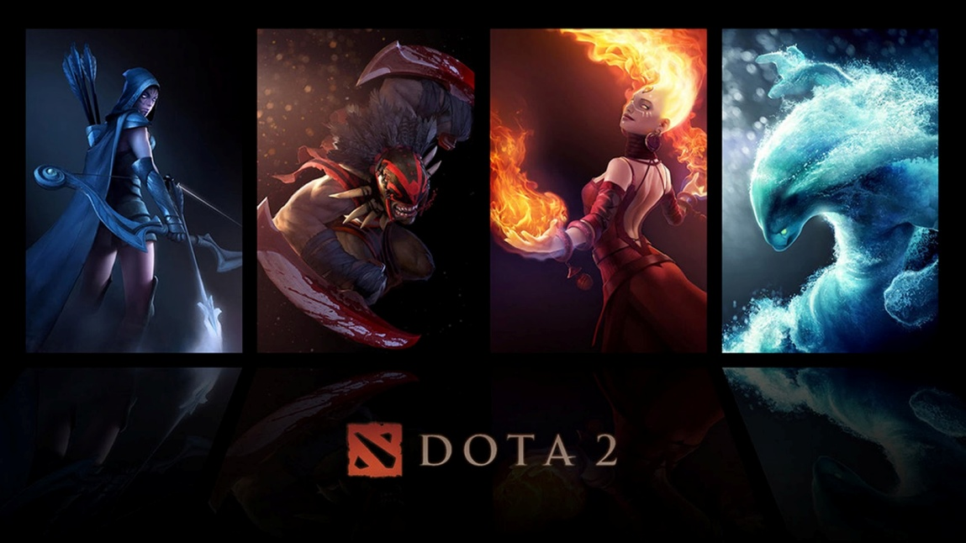

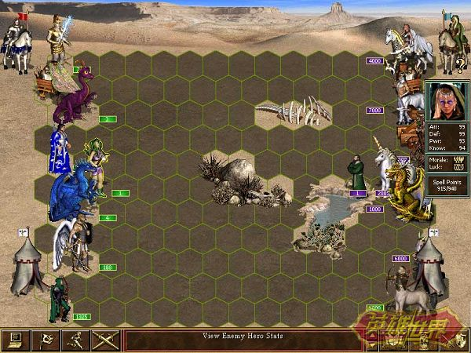

**Team Name: C-DOTA**

**Team Member: Ding Xiang Fei && Wang YanHao**

**Type: RPG + Board Game**

**Platform: Windows, Android, (IOS?)**